1/ Upon opening Backstage, look for the place new order tab
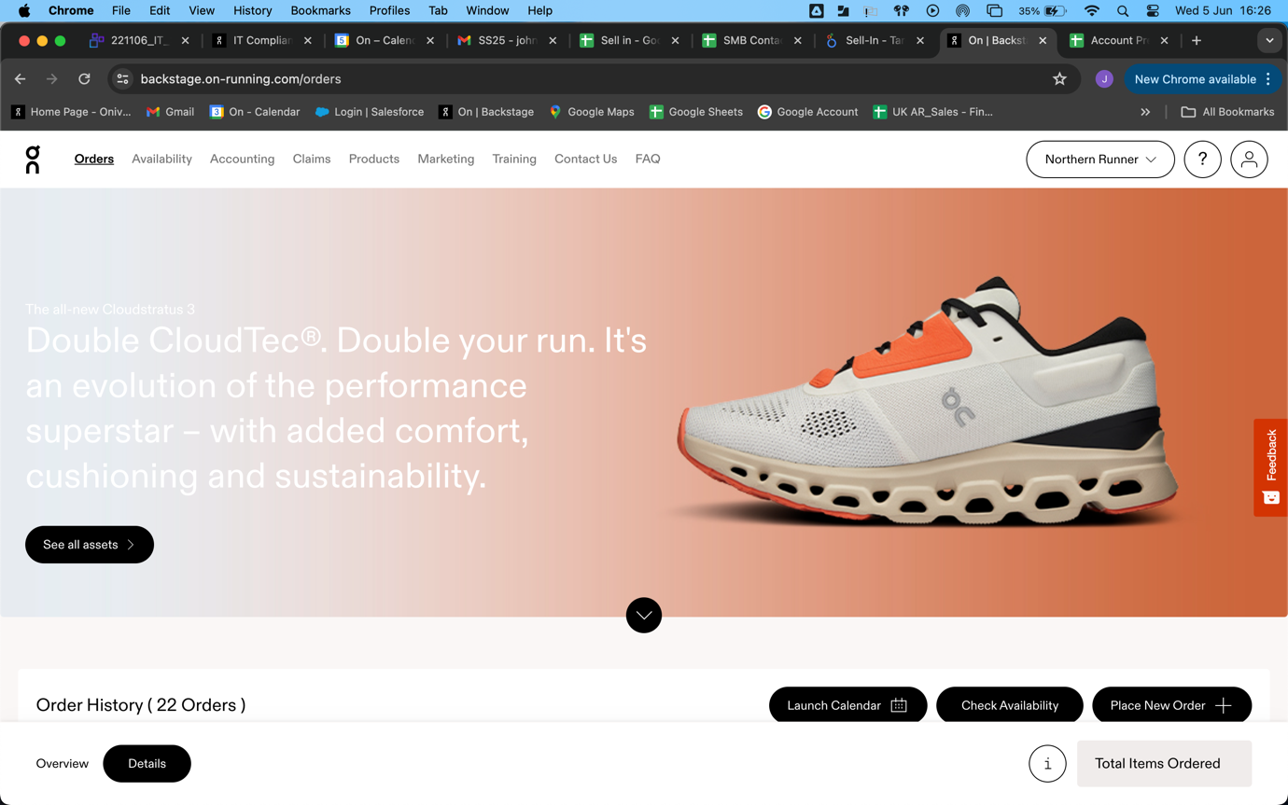

2/ You will be prompted with the type of order you wish to place, select Pre-Order or Pre-Order (Multiple ship date) [The latter is quicker if you know there are likely to be multiple shipments throughout the season required]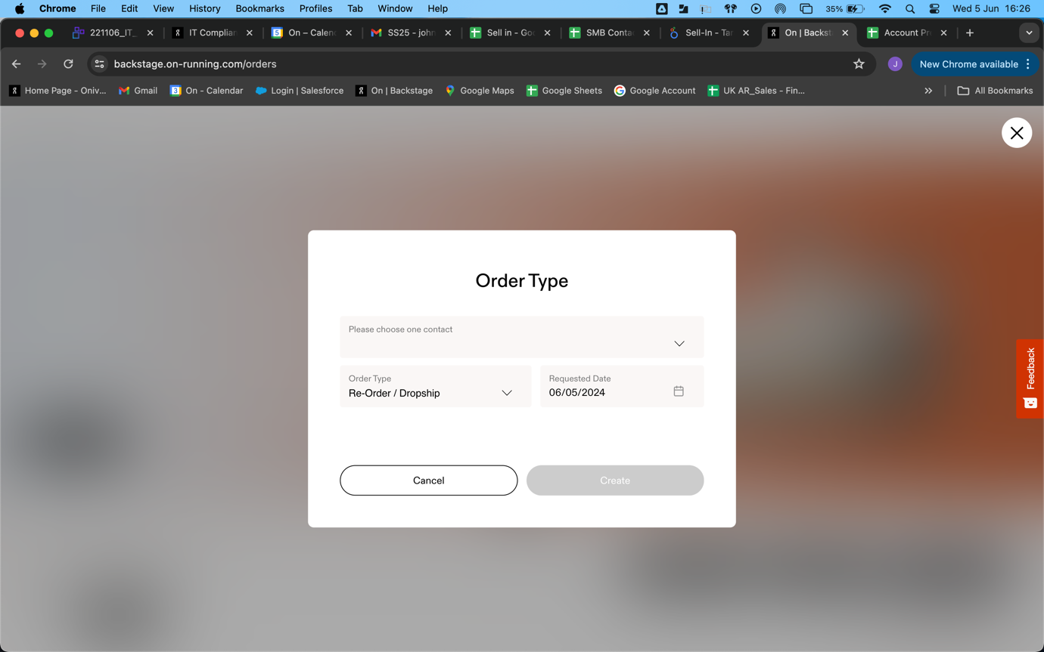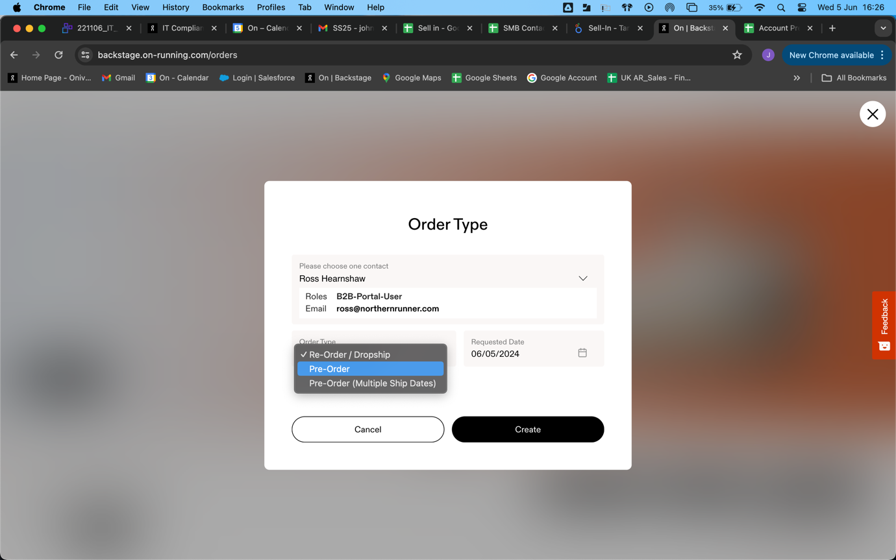

3/ This screen allows you to select all products you’re interested in. Click the image to select the styles required. It will be highlighted in yellow upon selection. Choose as many styles as required. Once complete, click ‘select quantities’.

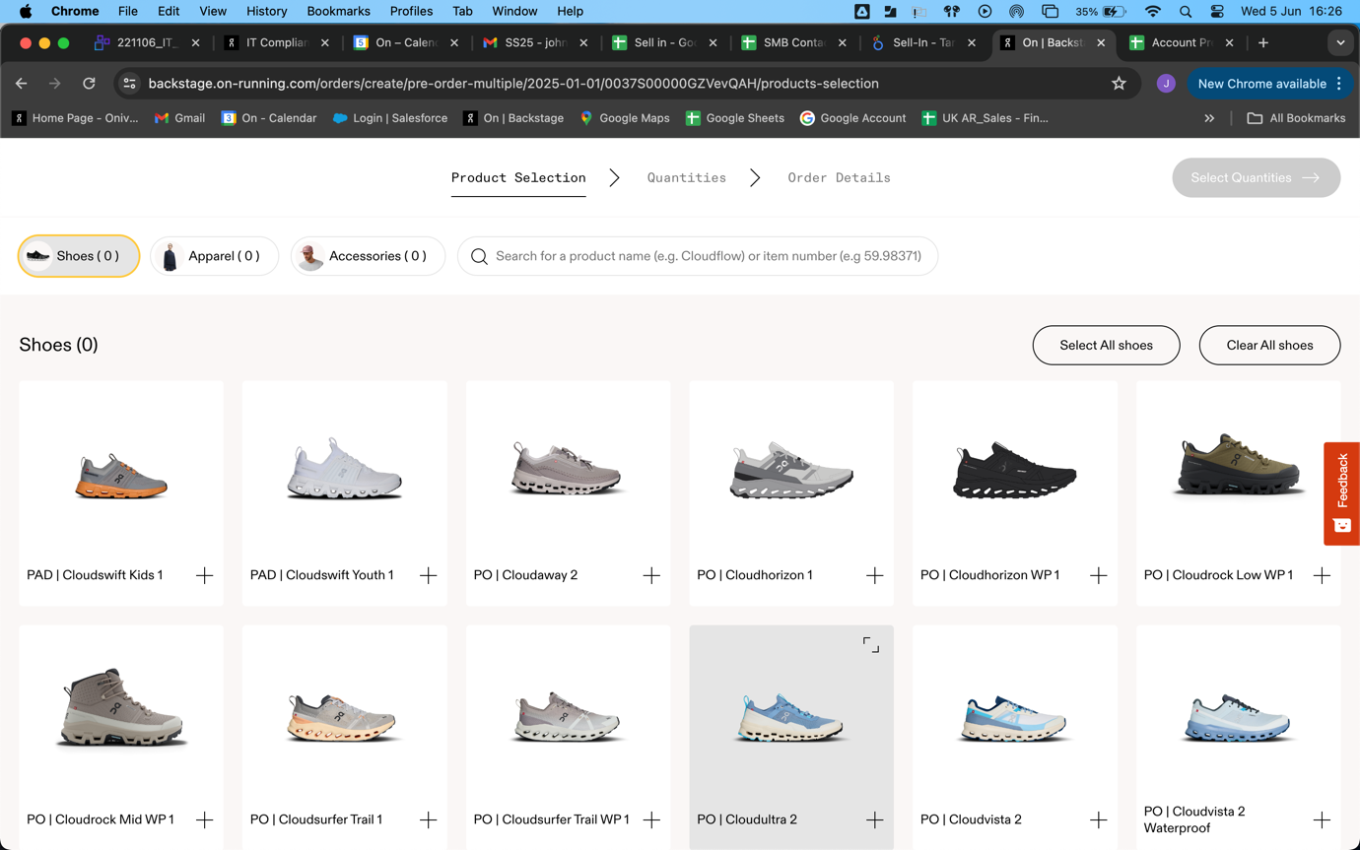

4/ Simply select the numbers you require. UK sizes should be in bold but double check before selecting and amend if required.

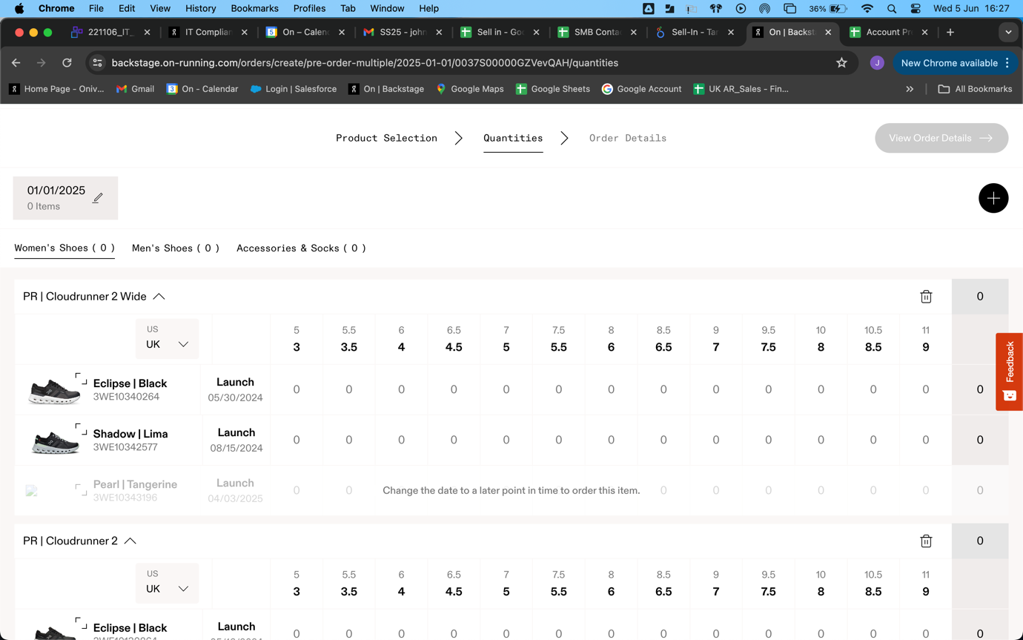

5/ Once your style(s) are selected for a delivery, if multiple ship dates are required, you can add another order (circled). Change to your required date and select numbers again. Repeat as necessary. 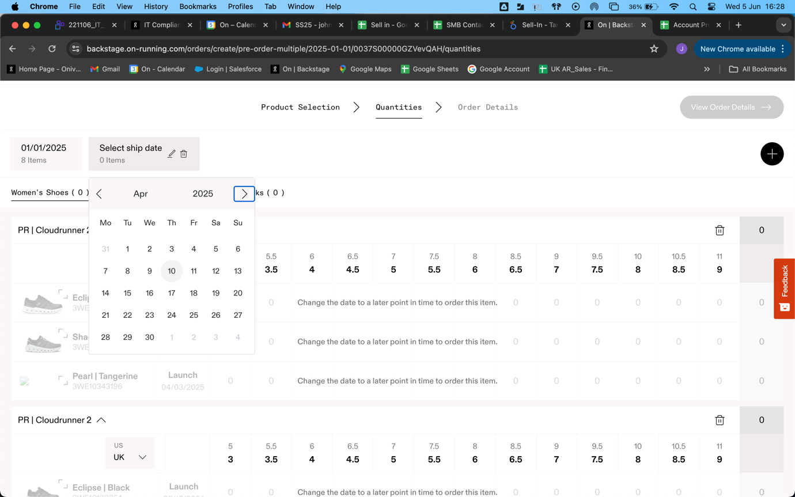

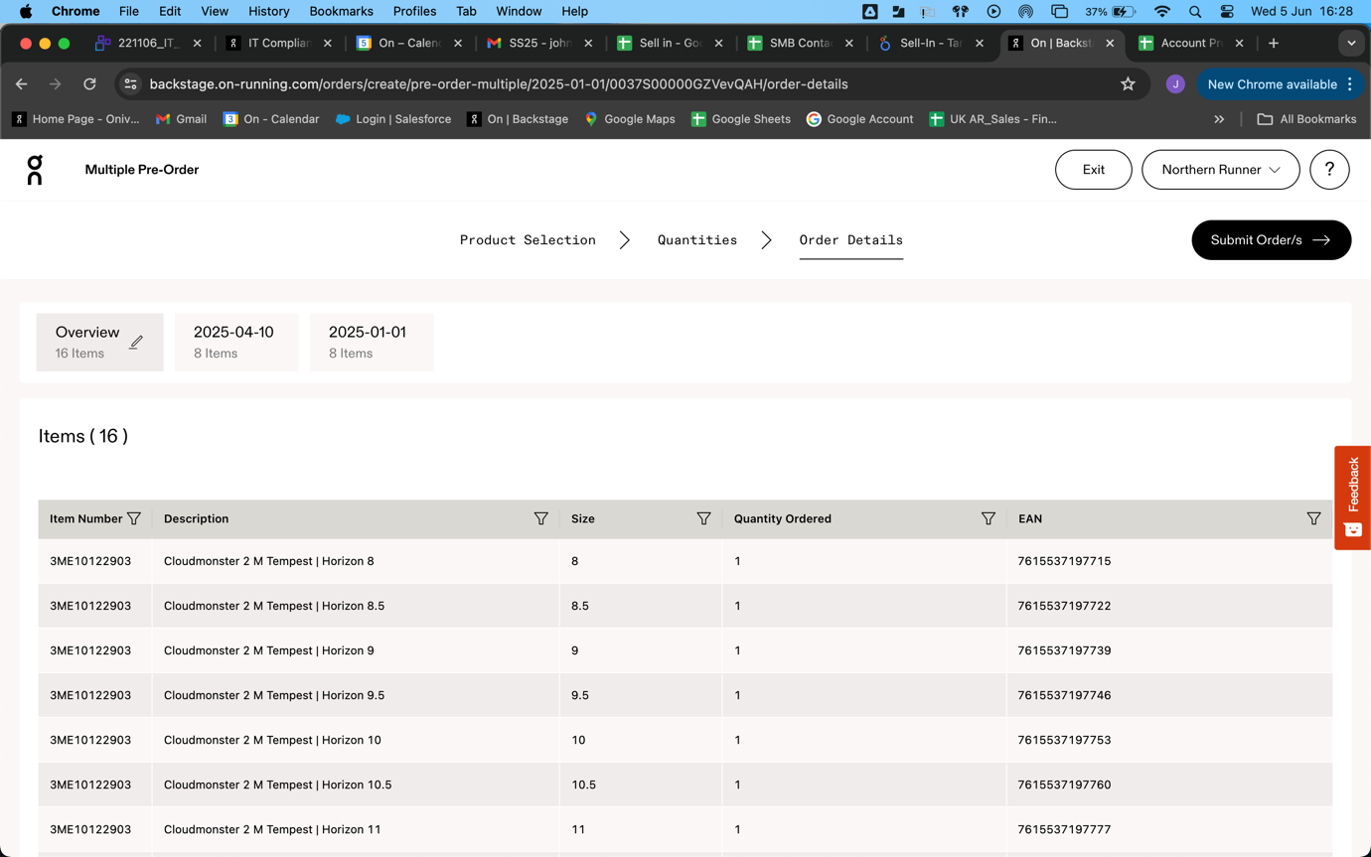
6/ Once complete, click ‘View Order Details’ for a summary of your order(s). If multiple ship dates are selected, the first window will show the season order. You can click into each specific date order to review individually if required.

7/ Upon opening the individual orders, you can select individual PO’s for each order if required.
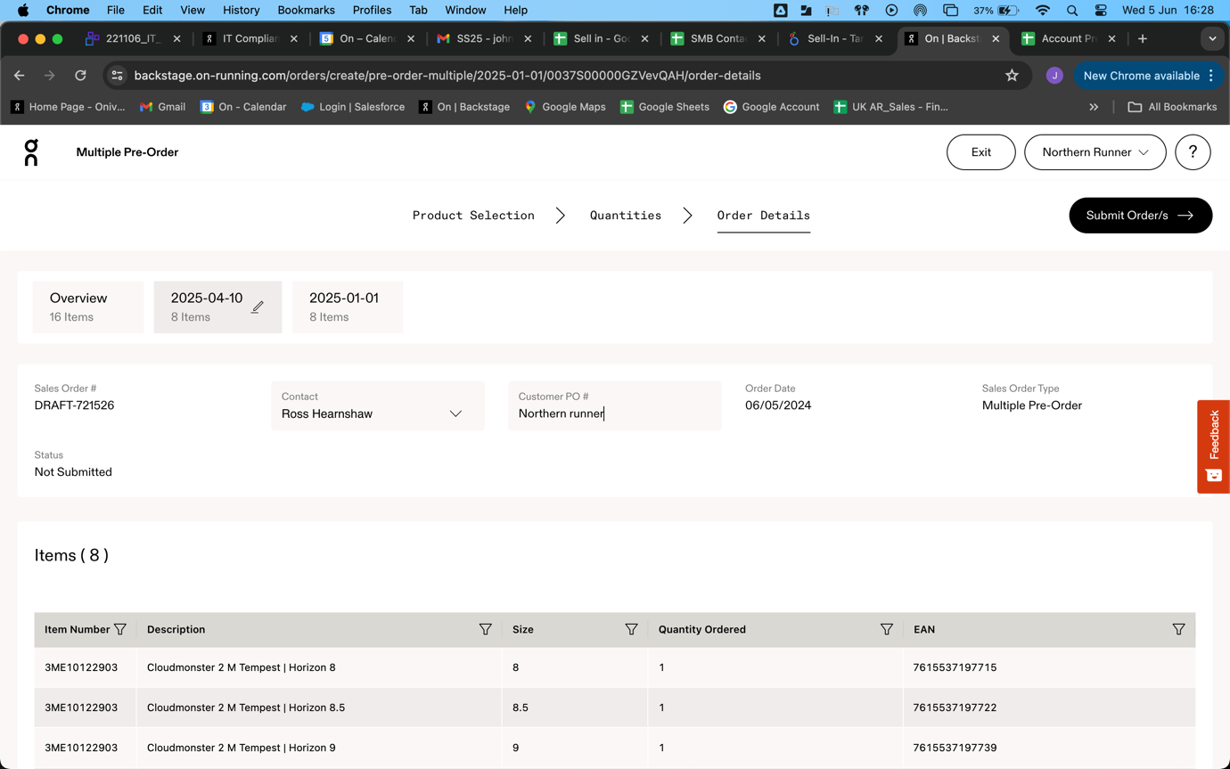
8/ Finally you can choose to submit the order if you are happy…..

…. Or by selecting ‘Exit’ you will be prompted to delete the order, save for later as a draft to continue editing later, or submit the order.

